09/27/2025, Legacy (last week)

https://www.youtube.com/live/oYpNM6QuAQA?si=pzJg_yjW9PICLjaN

“Waging Peace: Bringing Hope to a World at War,” Phil EuBank, Lead Pastor

The main point of "Waging Peace: Bringing Hope to a World at War" is to provide a spiritual and active framework for individuals and communities to become agents of peace by rejecting cultural division and fear, and instead embodying a life of courage, compassion, and proactive action rooted in faith in Jesus Christ and His teachings. It calls for a countercultural response to conflict and polarization, advocating for hope and unity to foster a world transformed by the principles of nonviolence and love for one's neighbor.

Key Themes and Concepts

* **Rejection of Division and Outrage**:

The message emphasizes that "waging peace" means refusing to be discipled by cultural outrage, political polarization, and social division.

* **Countercultural Community**:

It encourages the church to be a community that stands against prevailing cultural trends, embodying an alternative way of life based on the teachings of Jesus.

* **Spiritual Warfare**:

The concept of "waging peace" is framed as an "invisible war" against spiritual powers that promote fear, worry, and self-protection, rather than a literal war against other people.

* **Action and Hope**:

The message is a call to action, encouraging people to put aside despair and complacency to choose hope, courage, and commitment.

* **Faith in Jesus Christ**:

The teachings of Jesus are presented as the ultimate solution to the world's brokenness and conflict, offering peace with God and inspiring hope for all people.

* **Nonviolent Action**:

It draws inspiration from spiritual traditions and activists who have demonstrated the power and effectiveness of organized nonviolent actions for peacemaking.

* **Focus on the Divine Prodigal**:

The message offers a vision of humanity as "divine prodigals" who can find a way back to God and experience reconciliation through faith and commitment.

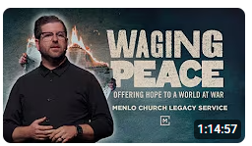

Phil EuBank, Lead Pastor

Introduction:

10:00/1:14:57

 



Rochelle, Pastor

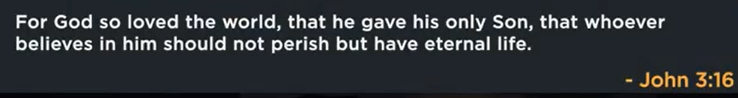

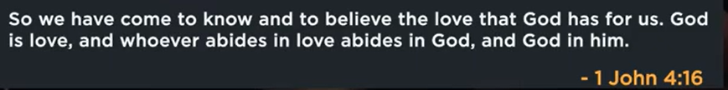

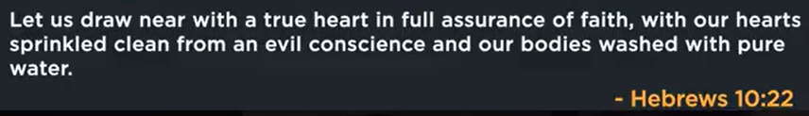

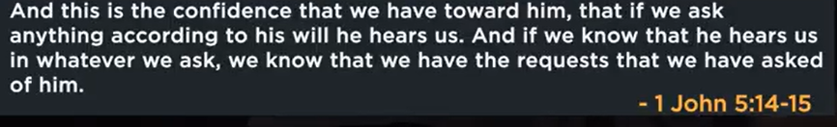

Tonight is the elder night.



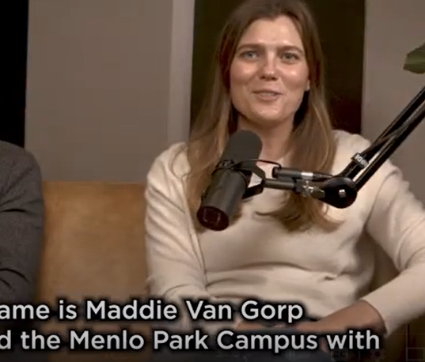

Maddie Van Gorp

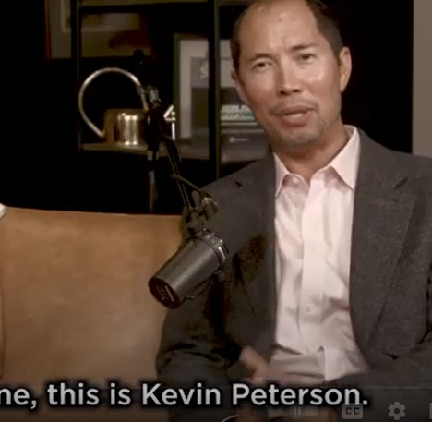

Kevin Peterson

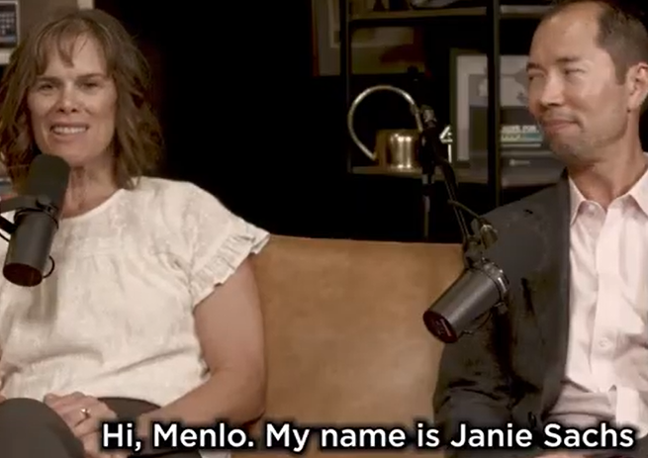

Janie Sachs

20:00/1:14:57

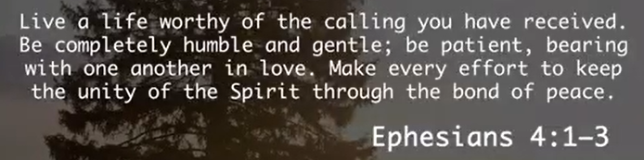

Ephesians 4:1-3

The main point of Ephesians 4:1-3 is an urgent call for believers to live a life worthy of their calling by actively maintaining the spiritual unity of the Church through humility, gentleness, patience, and love. The passage stresses that while this unity is a spiritual reality already given by the Holy Spirit, it requires diligent effort from believers to be preserved and expressed in their relationships with one another.

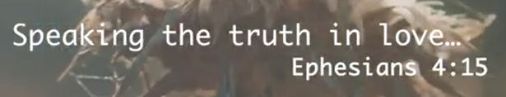

Ephesians 4:15

The main point of Ephesians 4:15 is that Christians should mature into Christlike wholeness by speaking the truth with love, which builds up the church and prevents falling for false doctrines. The verse teaches that truth spoken without love can be brutal, and love without truth is hypocritical; thus, both the integrity of the message and the spirit in which it's delivered are equally important for spiritual growth and church unity.

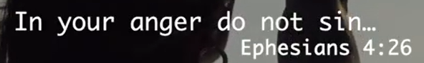

Ephesians 4:26

The main point of Ephesians 4:26 is to address and resolve anger quickly, preventing it from festering into sin, bitterness, or a foothold for the devil. It emphasizes that while anger is an emotion, not inherently sinful, it must be managed by dealing with the issue that caused it before the day ends, rather than allowing it to become a prolonged, destructive state or giving Satan an opportunity to influence one's actions.

24:50/1:14:57

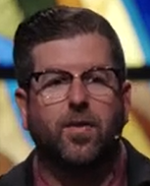 

We shift topic today.

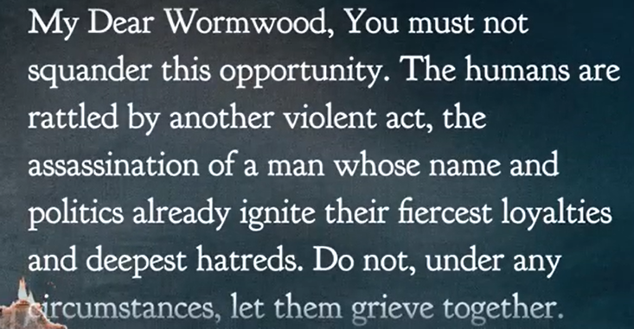

My Dear Wormwood, you must not squander this opportunity. The humans are rattled by another violent act; the assassination of a man whose name and politics already ignite their fiercest loyalties and deepest hatreds. Do not, under any circumstance, let them grieve together.

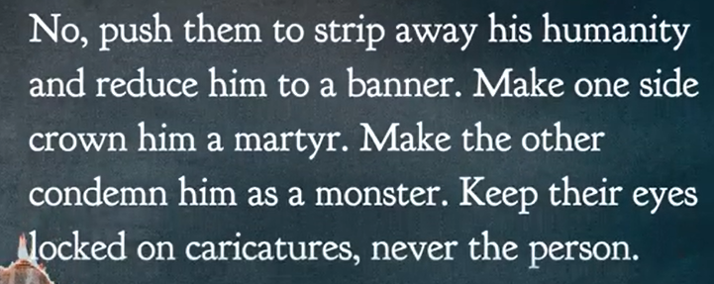

My Dear Wormwood, you must not squander this opportunity. The humans are rattled by another violent act; the assassination of a man whose name and politics already ignite their fiercest loyalties and deepest hatreds. Do not, under any circumstance, let them grieve together.

No, push to strip away his humanity and reduce him to a banner. Make one side crown him a martyr. Make the other condemn him as a monster. Keep their eyes blocked on caricatures, never the person.

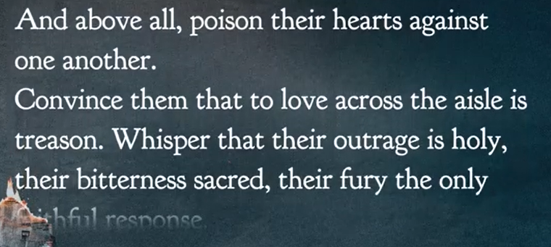

My Dear Wormwood, you must not squander this opportunity. The humans are rattled by another violent act; the assassination of a man whose name and politics already ignite their fiercest loyalties and deepest hatreds. Do not, under any circumstance, let them grieve together.

No, push to strip away his humanity and reduce him to a banner. Make one side crown him a martyr. Make the other condemn him as a monster. Keep their eyes blocked on caricatures, never the person.

And Above all, [poison their hearts against one another.

Convince them that to love across the aisle is treason. Whisper that their outrage is holy their bitterness sacred, their fury the only faithful response.

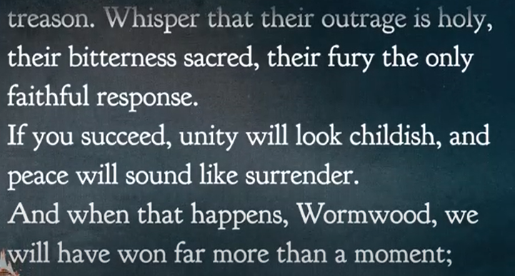

My Dear Wormwood, you must not squander this opportunity. The humans are rattled by another violent act; the assassination of a man whose name and politics already ignite their fiercest loyalties and deepest hatreds. Do not, under any circumstance, let them grieve together.

No, push to strip away his humanity and reduce him to a banner. Make one side crown him a martyr. Make the other condemn him as a monster. Keep their eyes blocked on caricatures, never the person.

And Above all, [poison their hearts against one another.

Convince them that to love across the aisle is treason. Whisper that their outrage is holy their bitterness sacred, their fury the only faithful response.

If you succeed, unity will look childish, and peace will around like surrender.

And when that happens, Wormwood, we will have won far more than a moment;

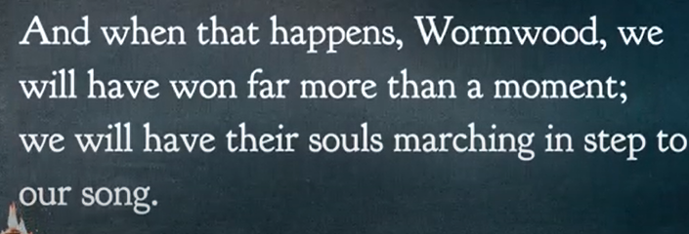

My Dear Wormwood, you must not squander this opportunity. The humans are rattled by another violent act; the assassination of a man whose name and politics already ignite their fiercest loyalties and deepest hatreds. Do not, under any circumstance, let them grieve together.

No, push to strip away his humanity and reduce him to a banner. Make one side crown him a martyr. Make the other condemn him as a monster. Keep their eyes blocked on caricatures, never the person.

And Above all, [poison their hearts against one another.

Convince them that to love across the aisle is treason. Whisper that their outrage is holy their bitterness sacred, their fury the only faithful response.

If you succeed, unity will look childish, and peace will around like surrender.

And when that happens, Wormwood, we will have won far more than a moment;

We will have their souls marching in step to our song.

C.S. Lewis

Clive Staples Lewis (29 November 1898 – 22 November 1963) was **a British writer, literary scholar and Anglican lay theologian**.

The text is not a genuine C.S. Lewis quote but a modern pastiche inspired by his writing style in *The Screwtape Letters*. In the fictional quote, the devil Screwtape advises his nephew Wormwood on how to exploit a human tragedy to sow division and poison people's hearts against one another.

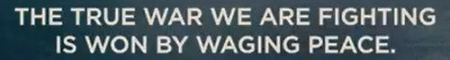

The true war we are fighting is won by waging peace

The pursuit of peace is more valuable than conflict or war. In this context, “waging war” is a metaphor for dedication, persistence, and strategic effort towards achieving peace. It emphasizes that peace isn't passive, but rather an active pursuit that requires commitment and resilience.



Don’t sacrifice your presence

The core message of "Don't sacrifice your presence" is to remain fully engaged in the present moment, prioritizing personal relationships and well-being over external pressures or future ambitions. It encourages investing time and energy in current relationships and moments rather than being solely focused on future career success or wealth accumulation.

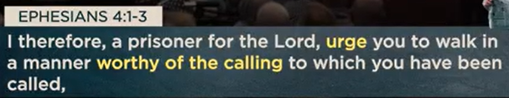

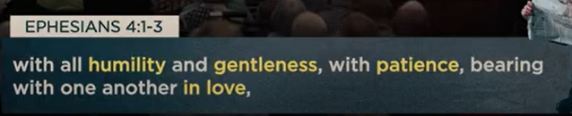

Ephesians 4:1-3

The main point of Ephesians 4:1-3 is that believers should live in a way that is worthy of their calling in Christ, actively striving to maintain unity within the church by displaying humility, gentleness, patience, and love towards one another.

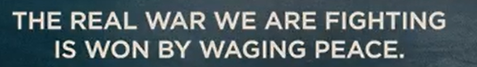

The real war we are fighting is won by waging peace.



Stand your ground on unity

While there is no universally recognized concept of "Stand your ground on unity," combining the two phrases creates a paradox, as one is about individual self-defense and the other is about collective harmony. The phrase could be interpreted in different ways depending on the context in which it is used.

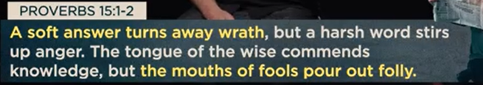

Proverbs 15:1-2

The main point of Proverbs 15:1-2 is the wisdom of responding to conflict with a soft, gentle answer, which de-escalates anger and promotes peace, contrasting with the foolishness of a harsh word, which provokes more conflict and stirs up anger.

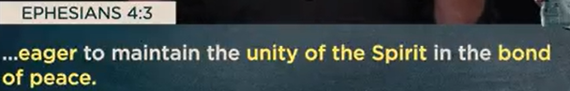

Because the politics can not satisfy our soul, we bring in the religion.

Hope does not mean ignore the reality.

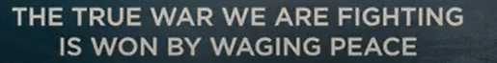



Don’t surrender your voice

The main point of "Don't surrender your voice" is that you must **stand in your own truth and speak authentically, without silencing yourself to please or appease others**. It is a call to protect your inner integrity and express your unique perspective, even when it is difficult or meets resistance.

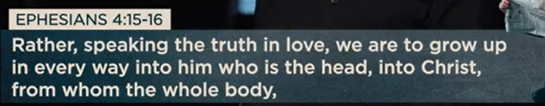

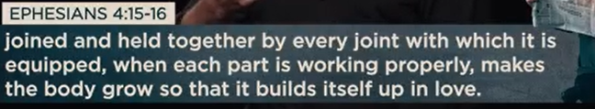

Jesus offers conviction and compassion.

Ephesians 4:15-16

The main point of Ephesians 4:15-16 is that believers, acting as distinct but interdependent parts of Christ's body, are to speak the truth in love to each other, thereby maturing into the likeness of Christ and collectively building up the church into a loving, healthy spiritual organism. This communal growth happens when each individual part of the body functions properly, contributing its share to the overall edification of the whole body.

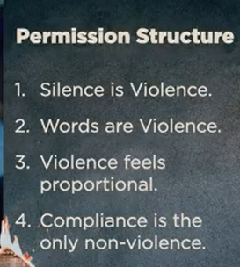

Permission structure

1. Silence is violence

2. Words are violence

3. Violence feels proportional

4. Compliance is the only non-violence

The "permission structure" described by the points "1. Silence is violence, 2. Words are violence, 3. Violence feels proportional, 4. Compliance is the only non-violence" refers to a framework that normalizes and justifies aggression. The main point is that it creates an environment where **any action can be framed as a necessary and justified response to a perceived harm**, ultimately leading to the demand for unconditional compliance.

The "permission structure" described by the points "1. Silence is violence, 2. Words are violence, 3. Violence feels proportional, 4. Compliance is the only non-violence" refers to a framework that normalizes and justifies aggression. The main point is that it creates an environment where **any action can be framed as a necessary and justified response to a perceived harm**, ultimately leading to the demand for unconditional compliance.

This is distinct from the more traditional political or psychological use of the term "permission structure," which describes a mechanism for allowing people to change their opinions without losing face. The points you provided represent a specific, critical reinterpretation of the term.

The main points of this aggressive permission structure can be broken down as follows:

* **Silence is violence:** This point mandates vocal agreement and participation. It asserts that refusing to speak out in support of a cause is not a neutral act, but an active endorsement of a perceived injustice. This creates pressure for public displays of support and demonizes dissent or neutrality.
* **Words are violence:** This point redefines verbal disagreement as a form of physical harm. By equating speech with violence, it justifies a physical or aggressive response to offensive language. This blurs the line between speech and action, legitimizing aggression against those whose words are deemed unacceptable.
* **Violence feels proportional:** This provides a psychological justification for escalation. Once words are defined as violence, and silence is defined as complicity, any aggressive response—verbal or physical—can be rationalized as a proportional reaction to the perceived initial "violence" of speech or silence.
* **Compliance is the only non-violence:** This is the concluding demand of the structure. It establishes that the only way to avoid being labeled as an aggressor or an accomplice is to fully and uncritically comply with the movement's demands. Any form of disagreement or non-participation is framed as an act of "violence," leaving no room for dissent.

This framework has been observed in online social media dynamics, where it has been described as a "Digital Permission Structure for Political Violence." It normalizes and incentivizes political violence by making it seem like a morally coherent and socially rewarded form of activism.

44:00/1:14:57



Don’t arm yourself with anger

The main point of the phrase "Don't arm yourself with anger" is that **choosing to rely on anger as your primary tool or defense mechanism is ultimately self-destructive**. While anger can be a natural human emotion, using it as a weapon can cause significant harm to yourself and your relationships, rather than to the person who originally upset you.

Real world we live are waging peace.

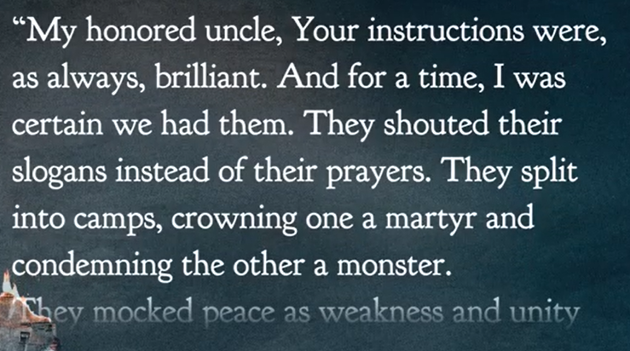

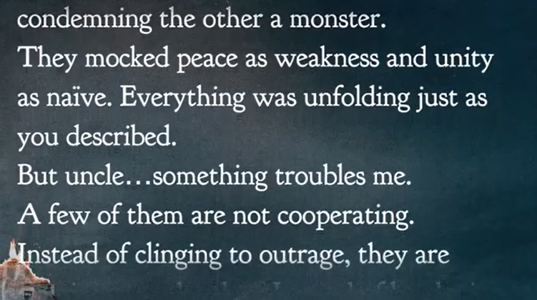

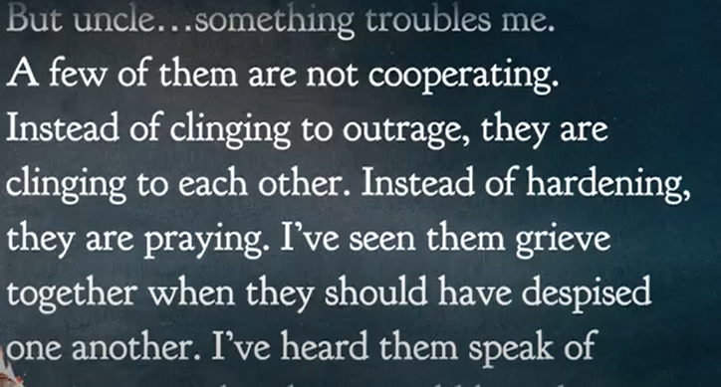

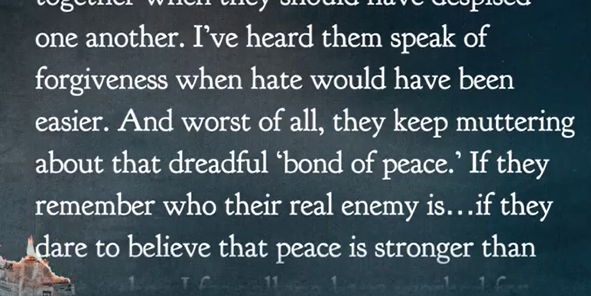

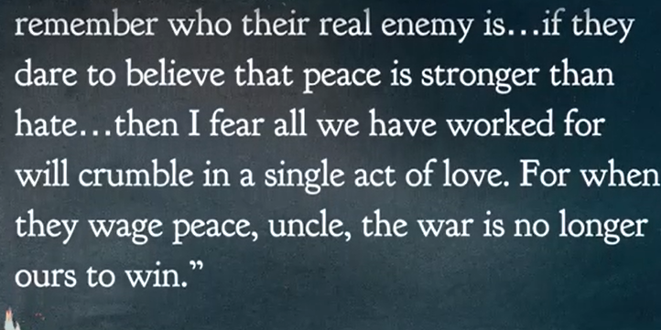

09/27/2025, Legacy (last week)

https://www.youtube.com/live/oYpNM6QuAQA?si=pzJg_yjW9PICLjaN

“Waging Peace: Bringing Hope to a World at War,” Phil EuBank, Lead Pastor

Summary:

Avoid conflict and embrace unity, courage, compassion, and faith.

1. Ephesians 4:1-3: Christian life is humility, gentleness, patience, and love with others.

2. Ephesians 4:15: Christians speak truth with love.

3. Ephesians 4:26: Anger is an emotion, not inherent sin. Anger must be end before the day ends.

4. C.S. Lewis write “*The Screwtape Letters*”: devil Screwtape asks his nephew Wormwood to divide human hearts.

5. “The true war we are fighting is won by waging peace”: Pursuit peace is better than conflict.

6. "Don't sacrifice your presence": Invest time and energy in current rather than future.

7. Ephesians 4:1-3: Maintain unity by humility, gentleness, patience, and love to other.

8. "Stand your ground on unity": We need self-defense and harmony.

9. Proverbs 15:1-2: Response conflict with soft word instead of harsh word.

10. Don't surrender your voice: Stand in your own truth without silencing yourself.

11. Ephesians 4:15-16: When each part of the body are good, the whole body will be good.

12. Permission structure:

a. Silence is violence: Do not keep Silence. Silence endorses injustice

b. Words are violence: Offensive words are unacceptable.

c. Violence feels proportional: Any offensive response proportion to violence.

d. Compliance (遵守规则) is the only non-violence: Compliance is the only way to avoid the violence.

13. "Don't arm yourself with anger": Anger hurt yourself and your relationships, not hurt the person who upset you.